Investigation of Regeneration Methods for Spent Catalytic Reforming Catalysts

Diyora Umarova, Shukxratqodir Gulomov, Guzal Yusupova, Jasur Ergashev, Ruslan Khabipov

Tashkent Institute of Chemical Technology, Tashkent, Uzbekistan. umarovadiyora703@gmail.com

Abstract
The regeneration of spent catalytic reforming catalysts remains a critical challenge in petroleum refining because catalyst deactivation is governed not only by coke deposition, but also by sulfur poisoning, pore blockage, chlorine loss and deterioration of the metal–acid balance. In this work, a spent industrial Pt–Re/γ-Al₂O₃–Cl reforming catalyst was regenerated through controlled oxidation, hydrogen reduction and oxychlorination-assisted treatment. The structural, textural and surface changes were evaluated by TGA/DTG, N₂ adsorption–desorption, XRD, SEM–EDS mapping, NH₃-TPD, H₂ uptake and catalytic performance testing.
The spent catalyst showed a strong decrease in BET surface area from 190 to 128 m² g⁻¹, pore volume from 0.47 to 0.31 cm³ g⁻¹, and catalytic conversion from 82.4 to 39.5%, mainly due to 8.60 wt.% coke deposition and partial loss of chlorine-related acidity. Controlled oxidation at 500 °C removed 81.4% of coke and restored conversion to 68.5%, whereas more severe oxidation at 550 °C achieved deeper decoking but lower catalytic recovery, indicating partial Pt–Re sintering and chlorine depletion. Hydrogen treatment improved metallic function, increasing activity recovery to 82.3%. The best performance was obtained after oxychlorination followed by H₂ reduction, which restored chlorine content, improved Pt–Re accessibility and achieved 79.6% conversion, 66.0% aromatics selectivity, 2.67 wt.% H₂ yield and 93.5% activity recovery.
These results demonstrate that efficient regeneration of spent reforming catalysts is controlled by the simultaneous recovery of pore accessibility, Pt–Re metallic function and chlorine-related acidity rather than by maximum coke removal alone.

Keywords: spent reforming catalyst; Pt–Re/γ-Al₂O₃–Cl; catalyst regeneration; coke removal; oxidative regeneration; oxychlorination; metal–acid balance; catalytic performance recovery.

1. Introduction
Catalytic naphtha reforming is a key petroleum refining process for producing high-octane gasoline components, aromatics and hydrogen for downstream hydrotreating units (Aznárez et al., 2024; Keivanimehr et al., 2025). Industrial reforming catalysts are typically bifunctional systems, where Pt-group metals provide hydrogenation–dehydrogenation activity, while chlorinated γ-Al₂O₃ supplies acid sites for isomerization, cyclization and controlled cracking reactions (Mazzieri et al., 2005; Batista, 2019). Among them, Pt–Re/γ-Al₂O₃–Cl catalysts are widely used because Re improves stability and resistance to deactivation compared with monometallic Pt catalysts (Pieck et al., 2005).
During long-term operation, these catalysts gradually lose activity due to coke deposition, sulfur poisoning, pore blockage, chlorine loss and metallic particle growth (Baghalha et al., 2010; Bare et al., 2017; Borgna et al., 2000; Borgna et al., 2009). Coke can accumulate on both external and internal pore surfaces, decreasing accessible surface area and pore volume (Baghalha et al., 2010). Spectroscopic studies have shown that coke on Pt–Re/γ-Al₂O₃ is structurally heterogeneous and may contain less condensed carbon species as well as more stable aromatic or graphitic deposits (Bare et al., 2017). Related studies on chloride and sulfur compound removal also show that halogen- and sulfur-containing impurities strongly influence the stability and functional accessibility of alumina-based catalytic and adsorbent systems. Yunusov et al. (2020) demonstrated the importance of chloride compound removal, while Yunusov et al. (2024) showed that sulfur-control catalysts based on aluminium-containing materials can be important for refinery purification processes. Therefore, deactivation of spent reforming catalysts is not only a decoking problem, but a combined deterioration of pore accessibility, metal dispersion and chlorine-related acidity.
Regeneration is essential for extending catalyst lifetime and reducing refinery operating costs. Conventional regeneration involves controlled oxidative coke burning followed by reduction of metallic sites (Le Normand et al., 1996; Arteaga et al., 2000). However, excessive oxidation can promote Pt–Re sintering, support restructuring and chlorine depletion, which may reduce catalytic recovery despite deeper coke removal (Arteaga et al., 2000; Dong et al., 2024). Oxychlorination is therefore important for Pt-based reforming catalysts because it can assist metal redispersion and restore chlorine-related acidity (Arteaga et al., 2000; Choi et al., 2020). Recent studies also emphasize that efficient regeneration requires the simultaneous recovery of metallic and acidic functions rather than coke removal alone (Choi et al., 2020; Pham et al., 2016). In addition, recent work on mineral-based demercaptanization catalysts confirms that sulfur-containing feed impurities remain an important factor in designing stable and energy-efficient catalytic purification systems (Yusupova et al., 2026).
Although coke formation, metal sintering and catalyst regeneration have been widely studied, the direct relationship between coke removal, pore reopening, Pt–Re metallic function, chlorine-related acidity and catalytic performance recovery remains insufficiently integrated for spent industrial reforming catalysts. In this work, a spent industrial Pt–Re/γ-Al₂O₃–Cl reforming catalyst was regenerated by controlled oxidation, hydrogen reduction and oxychlorination-assisted treatment. The main objective was to identify an optimized regeneration route by correlating structural, textural, elemental and catalytic changes. The novelty of this study is to demonstrate that the best regeneration efficiency is achieved not by the most severe decoking condition, but by restoring the complete bifunctional catalyst system.

2. Materials and Methods

2.1. Catalyst samples and regeneration routes
A commercial spent Pt–Re/γ-Al₂O₃–Cl reforming catalyst was used as the main sample and compared with the corresponding fresh catalyst. Before analysis, the spent catalyst granules were separated from dust and fines, dried at 110 °C for 4 h, and stored in sealed containers. The samples were denoted as Fresh and Spent.
Regeneration was performed through controlled oxidation, hydrogen reduction and oxychlorination-assisted treatment. Oxidative regeneration was carried out in flowing air at 500 °C and 550 °C for 4 h with a heating rate of 5 °C min⁻¹. The corresponding samples were named O-500 and O-550. The O-500-H₂ sample was obtained by reducing O-500 under flowing H₂ at 450 °C for 3 h. The OxyCl–H₂ sample was prepared by oxychlorination followed by H₂ reduction to restore chlorine-related acidity and the metal–acid balance.

Table 1. Catalyst sample codes and treatment routes
Sample | Treatment route | Purpose
Fresh | Fresh catalyst | Reference
Spent | Industrially deactivated catalyst | Deactivation assessment
O-500 | Oxidation at 500 °C | Controlled decoking
O-550 | Oxidation at 550 °C | Severe decoking / sintering risk
O-500-H₂ | O-500 + H₂ reduction | Metallic function recovery
OxyCl–H₂ | Oxychlorination + H₂ reduction | Acid–metal balance recovery

2.2. Characterization methods
Coke content and oxidation behaviour were evaluated by TGA/DTG from 30 to 800 °C under oxidative atmosphere at 10 °C min⁻¹. Textural properties were determined by N₂ adsorption–desorption at −196 °C after vacuum degassing at 250 °C for 4 h. The BET surface area was calculated from adsorption data in the relative pressure range P/P₀ = 0.05–0.30. Total pore volume was estimated from the amount of nitrogen adsorbed at P/P₀ ≈ 0.99, and pore-size distribution was obtained by the BJH method using the desorption branch. Fresh, spent and regenerated catalysts were analysed under identical conditions.The phase structure was analyzed by XRD using Cu Kα radiation in the 2θ range of 3–90°. Surface morphology and elemental distribution were examined by SEM–EDS mapping for C, S, Cl and Pt–Re, allowing evaluation of coke deposition, sulfur enrichment, chlorine redistribution and metallic component dispersion. Acidity and metal accessibility were assessed by NH₃-TPD and H₂ uptake, respectively.

2.3. Catalytic performance evaluation
Catalytic performance was tested in a fixed-bed microreactor using a model naphtha reforming feed. The catalysts were activated under H₂ flow and tested at 500 °C, 5 bar and WHSV = 2 h⁻¹. Products were analyzed by gas chromatography. Catalyst performance was expressed as conversion, aromatics selectivity and H₂ yield. The corresponding activity recovery values and their discussion are presented in Section 3.4.

3. Results and Discussion

3.1. Deactivation state of the spent reforming catalyst
The spent industrial Pt–Re/γ-Al₂O₃–Cl reforming catalyst showed clear physicochemical signs of deactivation compared with the fresh reference sample. The fresh catalyst had a light grey colour and mechanically uniform granules, whereas the spent sample became dark grey to black, indicating the accumulation of carbonaceous deposits on the external surface and inside the pore network. Such changes are typical for bifunctional reforming catalysts, where deactivation occurs through the combined effects of coke deposition, poisoning of metallic sites, partial chlorine loss and deterioration of the metal–acid balance (Baghalha et al., 2010; Borgna et al., 2000; Digne et al., 2008; Anekwe and Isa, 2025).

Table 1. Physicochemical properties of fresh, spent and regenerated Pt–Re/γ-Al₂O₃–Cl catalysts
Sample | BET, m²/g | Pore volume, cm³/g | Coke, wt.% | S, wt.% | Cl, wt.% | Pt, wt.% | Re, wt.% | Strength, N/granule
Fresh | 190 | 0.47 | 0.20 | 0.02 | 1.05 | 0.29 | 0.31 | 58
Spent | 128 | 0.31 | 8.60 | 0.12 | 0.73 | 0.28 | 0.30 | 50
O-500 | 168 | 0.42 | 1.60 | 0.07 | 0.65 | 0.28 | 0.30 | 47
O-550 | 171 | 0.43 | 0.80 | 0.06 | 0.58 | 0.28 | 0.30 | 44
O-500-H₂ | 166 | 0.41 | 1.40 | 0.07 | 0.64 | 0.28 | 0.30 | 47
OxyCl-H₂ | 172 | 0.43 | 1.00 | 0.06 | 0.94 | 0.28 | 0.30 | 46
The BET surface area decreased from 190 to 128 m²/g, while the total pore volume decreased from 0.47 to 0.31 cm³/g. This confirms that the main structural consequence of industrial operation was pore blockage by coke and heavy hydrocarbon residues. The coke content increased from 0.20 to 8.60 wt.%, showing that carbon deposition was the dominant deactivation factor. However, the rise in sulfur content from 0.02 to 0.12 wt.% also indicates partial poisoning of Pt–Re metallic sites. Although the Pt and Re contents remained almost unchanged, their accessible surface was reduced because of coke coverage and possible particle growth.
The chlorine content decreased from 1.05 to 0.73 wt.%, suggesting partial loss or redistribution of chloride species. This is important because chlorinated alumina provides the acid function required for isomerization and cyclization reactions, while Pt–Re sites provide hydrogenation–dehydrogenation activity. Therefore, the activity loss of the spent catalyst cannot be explained by coke alone. It results from the simultaneous deterioration of textural accessibility, metallic function and acid function.

3.2. Effect of regeneration on coke removal and textural recovery
The coke removal behaviour was evaluated by comparing thermal, oxidative and hydrogen-assisted regeneration routes. Thermal treatment at 500 °C under inert atmosphere removed only part of the carbonaceous deposits, indicating that simple desorption or thermal decomposition is insufficient for deep regeneration. In contrast, oxidative treatment was more effective because it converted coke into gaseous oxidation products and reopened blocked pores.
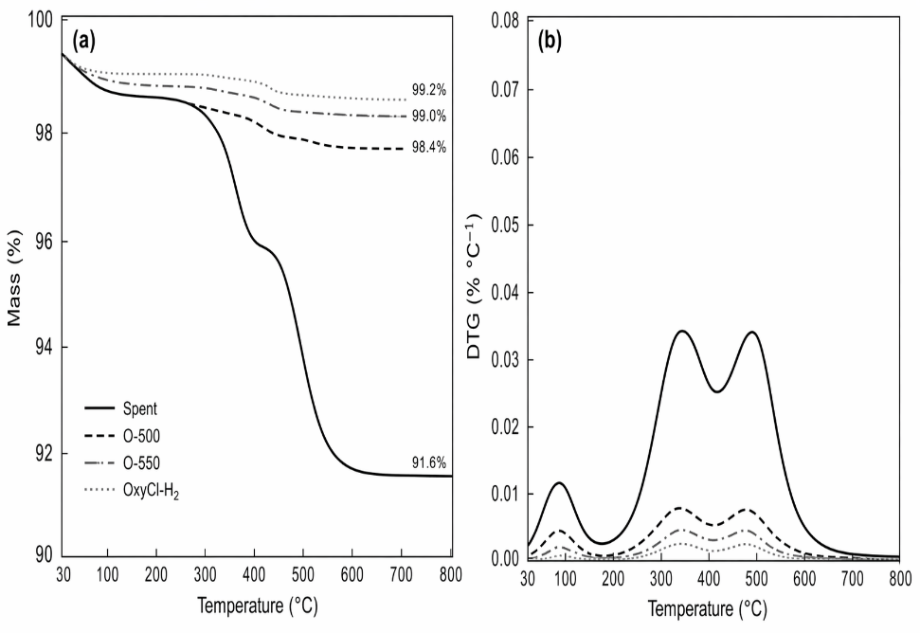
Figure 1: TGA/DTG profiles of spent and regenerated catalysts.
The TGA/DTG profile of the spent catalyst is discussed in three temperature regions. The first region below 180 °C corresponds mainly to adsorbed water and light hydrocarbons. The second region between 250 and 430 °C is attributed to less condensed amorphous coke. The third region between 430 and 600 °C is related to more stable polyaromatic or graphitic coke species (Arteaga et al., 2000; Choi et al., 2020; Pham et al., 2016). This confirms that coke deposited during reforming is heterogeneous and requires controlled oxidation rather than severe uncontrolled burning.

Table 2. Coke removal and activity recovery after regeneration
Sample | Regeneration route | Residual coke, wt.% | Coke removal, % | Activity recovery, %
Spent | — | 8.60 | 0 | 0
O-500 | Oxidation, 500 °C | 1.60 | 81.4 | 67.6
O-550 | Oxidation, 550 °C | 0.80 | 90.7 | 54.8
O-500-H₂ | O-500 + H₂ reduction | 1.40 | 83.7 | 82.3
OxyCl-H₂ | O-500 + oxychlorination + H₂ | 1.00 | 88.4 | 93.5
Oxidation at 500 °C decreased the coke content from 8.60 to 1.60 wt.% and increased the BET surface area from 128 to 168 m²/g, indicating pore reopening without excessive structural damage. Increasing the oxidation temperature to 550 °C further reduced coke to 0.80 wt.% and slightly increased the surface area to 171 m²/g, but this sample showed lower mechanical strength and poorer catalytic recovery. Thus, maximum coke removal did not correspond to maximum catalyst regeneration.
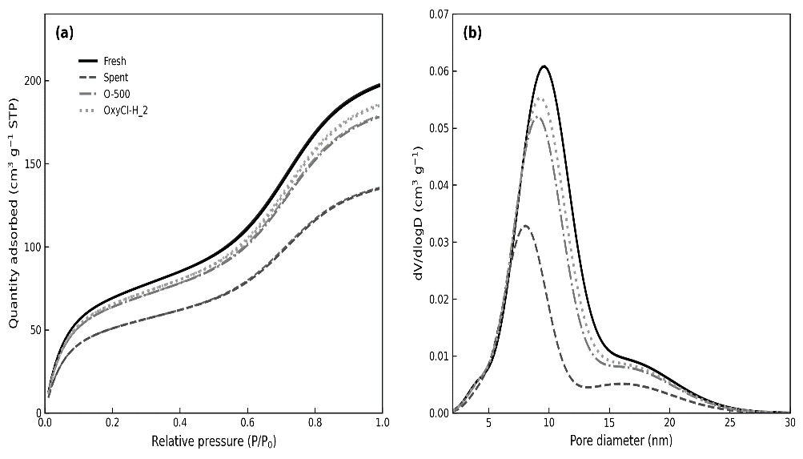
Figure 2: N₂ adsorption–desorption isotherms and pore-size distributions.
The N₂ adsorption–desorption curves show reduced nitrogen uptake for the spent catalyst and partial restoration after regeneration. Pore volume recovery from 0.31 to 0.42–0.43 cm³/g confirms reopening of blocked mesopores, although residual coke, contaminant retention or partial metal agglomeration prevented complete recovery. Thus, optimal decoking should balance coke removal, pore recovery and structural stability.

3.3. Metal dispersion, chlorine balance and bifunctional recovery
XRD analysis confirmed that the main γ-Al₂O₃ structure was preserved after operation and regeneration. The fresh catalyst showed broad reflections typical of γ-Al₂O₃, while intense Pt or Re reflections were absent, indicating high dispersion of the metallic phase below the detection limit of conventional XRD. The spent catalyst retained the same main support structure, but coke coverage and surface restructuring may reduce peak clarity.
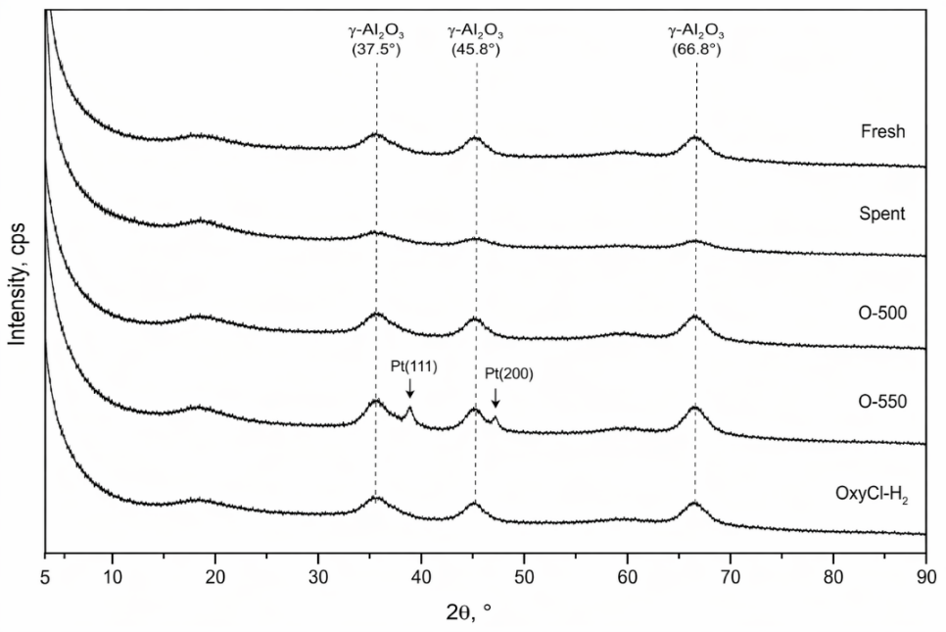
Figure 3: XRD patterns of fresh, spent and regenerated catalysts.
The O-500 sample retained broad γ-Al₂O₃ reflections without distinct Pt–Re diffraction peaks, indicating that controlled oxidation did not induce pronounced metallic sintering. In contrast, the O-550 sample exhibited slight peak sharpening in the high-angle region, suggesting partial growth of metallic particles under more severe oxidative conditions. This structural change is consistent with its lower catalytic recovery despite more complete coke removal, confirming that excessive oxidation may compromise metal dispersion and chlorine-related acidity.
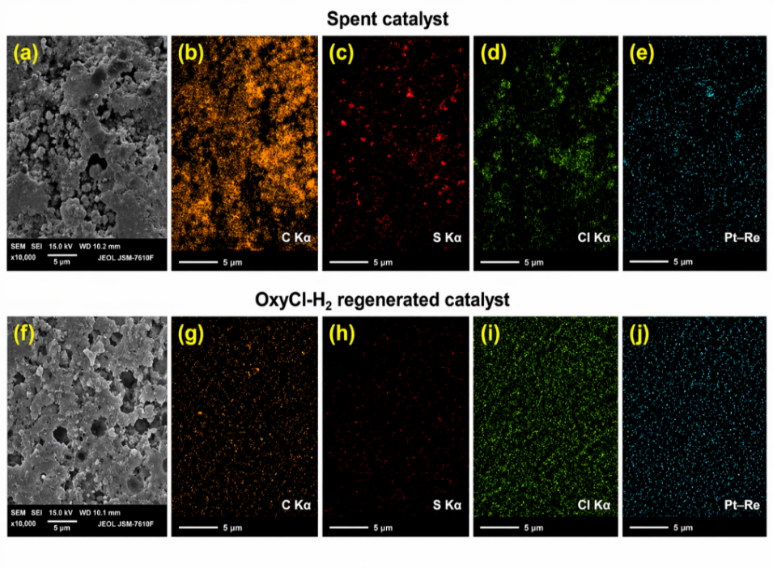
Figure 4: SEM–EDS mapping of spent and OxyCl–H₂ catalyst.
SEM–EDS mapping confirmed the surface-level changes responsible for catalyst regeneration (Figure 4). The spent catalyst showed a rough, partially blocked morphology with intense and heterogeneous C Kα signals, proving non-uniform coke deposition. Localized S Kα enrichment indicated partial poisoning of accessible Pt–Re sites, while the weak and uneven Cl Kα distribution suggested deterioration of chlorine-related acidity. After OxyCl–H₂ regeneration, the carbon and sulfur signals decreased markedly, whereas chlorine and Pt–Re became more uniformly distributed. These results demonstrate that the optimized regeneration route not only removed coke, but also partially restored the acid–metal balance required for catalytic reforming.

Table 3. Acid and metal function indicators
Sample | Cl, wt.% | Total acidity, mmol NH₃/g | Pt dispersion, % | H₂ uptake, μmol/g
Fresh | 1.05 | 0.42 | 58 | 72
Spent | 0.73 | 0.26 | 33 | 39
O-500 | 0.65 | 0.24 | 43 | 50
O-550 | 0.58 | 0.20 | 36 | 42
O-500-H₂ | 0.64 | 0.24 | 51 | 62
OxyCl-H₂ | 0.94 | 0.39 | 55 | 68
The spent catalyst showed a decrease in total acidity from 0.42 to 0.26 mmol NH₃/g and Pt dispersion from 58 to 33%. This confirms that deactivation affected both acid and metal functions. O-500 restored textural properties but did not restore chlorine-related acidity. O-500-H₂ improved Pt dispersion and H₂ uptake, confirming recovery of metallic function after reduction. The best bifunctional recovery was obtained for OxyCl-H₂, where chlorine content, total acidity and Pt dispersion approached the fresh catalyst values.
Thus, complete regeneration requires combined pore reopening, metal reactivation and acidity restoration.

3.4. Catalytic performance and regeneration mechanism
Catalytic performance confirmed the strong deactivation of the spent catalyst and the efficiency of the optimized regeneration route (Figure 5). The fresh catalyst exhibited 82.4% conversion, 68.3% aromatics selectivity, and 2.80 wt.% H₂ yield, whereas the spent catalyst decreased to 39.5%, 37.4%, and 1.10 wt.%, respectively. This indicates a substantial loss of both metallic and acidic functions during operation.
Oxidative regeneration at 500 °C restored the conversion to 68.5%, corresponding to 67.6% activity recovery. However, increasing the oxidation temperature to 550 °C reduced the conversion to 63.0%, despite stronger coke removal, suggesting partial metal sintering and chlorine loss. The O-500-H₂ sample showed improved performance with 74.8% conversion and 82.3% activity recovery, confirming the role of hydrogen treatment in restoring the metallic function.
The highest performance was obtained for the OxyCl–H₂ sample, reaching 79.6% conversion, 66.0% aromatics selectivity, and 2.67 wt.% H₂ yield, equivalent to 93.5% activity recovery. These results demonstrate that effective regeneration requires not only coke removal, but also recovery of Pt–Re metallic sites and chlorine-related acidity
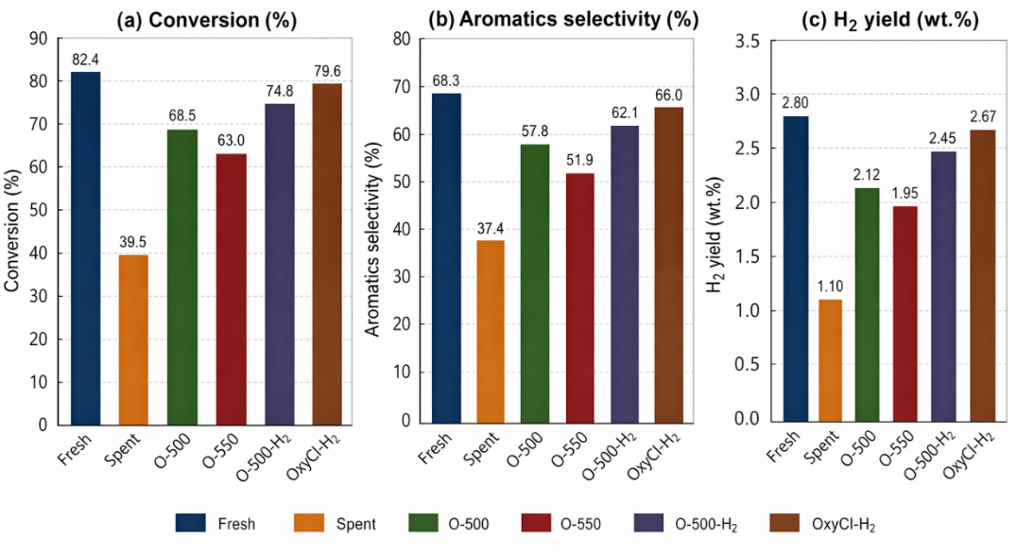
Figure 5: Catalytic performance of fresh, spent and regenerated catalysts.
The O-500 sample recovered 67.6% of the lost activity, showing that coke removal and pore reopening significantly improved catalyst performance. However, O-550 recovered only 54.8%, despite stronger coke removal. This confirms that excessive regeneration temperature can reduce catalytic performance through metal sintering, chlorine loss and weakening of the acid–metal balance.

Activity recovery was calculated using Eq(1):

Activity recovery(%)=[(X_{regenerated}−X_{spent})/(X_{fresh}−X_{spent})]×100 (1)

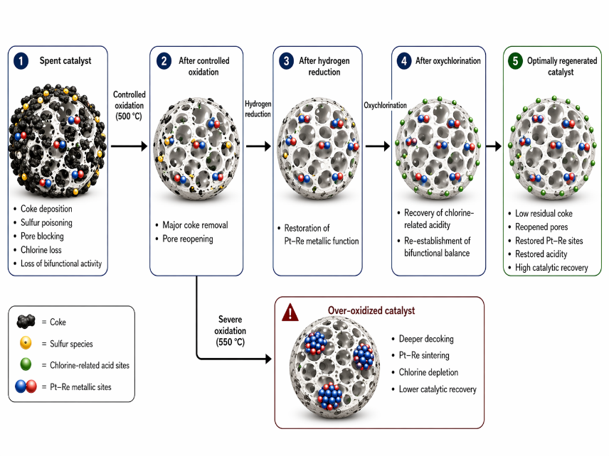
The O-500-H₂ sample achieved 82.3% activity recovery because hydrogen reduction improved the accessibility and metallic state of Pt–Re sites. The highest recovery, 93.5%, was obtained for OxyCl-H₂. This sample combined low residual coke, restored chlorine content, improved acidity and high Pt dispersion. Therefore, it provided the best balance between structural recovery and catalytic function.
Figure 6: Proposed regeneration mechanism
Figure 6 summarizes the proposed regeneration pathway. The spent Pt–Re/γ-Al₂O₃–Cl catalyst deactivates through coke deposition, sulfur poisoning, pore blockage, chlorine loss and reduced metal accessibility. Controlled oxidation at 500 °C removes coke and reopens pores; H₂ reduction reactivates Pt–Re sites, and oxychlorination restores chlorine-related acidity. Severe oxidation at 550 °C gives deeper decoking but promotes sintering and chlorine depletion. Therefore, the optimum route is governed by balanced recovery of pore accessibility, metallic dispersion and acidity.
The combined interpretation of TGA/DTG, BET, XRD, SEM–EDS, NH₃-TPD and H₂ uptake confirms that regeneration efficiency cannot be evaluated by a single indicator.

4. Conclusions
Spent Pt–Re/γ-Al₂O₃–Cl reforming catalyst deactivation was governed by the combined effects of coke deposition, pore blockage, sulfur poisoning, chlorine loss and deterioration of the metal–acid balance. The spent catalyst showed a marked decrease in surface area, pore volume and catalytic conversion, confirming severe loss of both textural accessibility and bifunctional activity.
Controlled oxidation at 500 °C effectively removed most coke and reopened the pore structure, while harsher oxidation at 550 °C caused lower catalytic recovery despite deeper decoking, indicating the negative effect of Pt–Re sintering and chlorine depletion. Hydrogen reduction improved the metallic function, but the best regeneration efficiency was achieved only when oxidation was combined with oxychlorination and H₂ reduction.
The OxyCl–H₂ route restored chlorine-related acidity, preserved Pt–Re accessibility and achieved 93.5% activity recovery, approaching the fresh catalyst performance. Therefore, efficient regeneration of spent reforming catalysts should be optimized not for maximum coke removal alone, but for balanced recovery of pore structure, metallic dispersion and acid functionality.

References
Anekwe I.M.S., Isa Y.M., 2025, Unlocking catalytic longevity: a critical review of catalyst deactivation pathways and regeneration technologies, Energy Advances, 4, 1075–1113, DOI: 10.1039/D5YA00015G.
Arteaga G.J., Anderson J.A., Rochester C.H., 2000, Effects of oxidation–reduction and oxychlorination–reduction cycles on Pt–Ge/Al₂O₃ catalysts, Journal of Catalysis, 189, 195–208, DOI: 10.1006/jcat.1999.2695.
Aznárez A., Korili S.A., Gil A., 2024, Progress and recent novelties in naphtha reforming catalysts, Journal of Environmental Chemical Engineering, 12, 113066, DOI: 10.1016/j.jece.2024.113066.
Baghalha M., Mohammadi M., Ghorbanpour A., 2010, Coke deposition mechanism on the pores of a commercial Pt–Re/γ-Al₂O₃ naphtha reforming catalyst, Fuel Processing Technology, 91, 714–722, DOI: 10.1016/j.fuproc.2010.02.002.
Bare S.R., Vila F.D., Charochak M.E., Prabhakar S., Bradley W.J., Jaye C., Fischer D.A., Hayashi S.T., Bradley S.A., Rehr J.J., 2017, Characterization of coke on a Pt–Re/γ-Al₂O₃ reforming catalyst: experimental and theoretical study, ACS Catalysis, 7, 1452–1461, DOI: 10.1021/acscatal.6b02785.
Batista A.T.F., 2019, Atomic scale insight into platinum based catalysts supported on chlorinated gamma-alumina, PhD Thesis, Université de Lyon, Lyon, France.
Borgna A., Garetto T.F., Apesteguia C.R., 2000, Simultaneous deactivation by coke and sulfur of bimetallic Pt–Re(Ge, Sn)/Al₂O₃ catalysts for n-hexane reforming, Applied Catalysis A: General, 197, 11–21, DOI: 10.1016/S0926-860X(99)00528-1.
Choi Y.S., Oh K., Jung K.D., Kim W.I., Koh H.L., 2020, Regeneration of Pt–Sn/Al₂O₃ catalyst for hydrogen production through propane dehydrogenation using hydrochloric acid, Catalysts, 10, 898, DOI: 10.3390/catal10080898.
Digne M., Raybaud P., Sautet P., Guillaume D., Toulhoat H., 2008, Atomic scale insights on chlorinated γ-alumina surfaces, Journal of the American Chemical Society, 130, 11030–11039, DOI: 10.1021/ja8019593.
D’Ippolito S.A., Vera C.R., Epron F., Samoila P., Especel C., Marécot P., Gutierrez L.B., Pieck C.L., 2009, Catalytic properties of Pt–Re/Al₂O₃ naphtha-reforming catalysts modified by germanium introduced by redox reaction at different pH values, Industrial & Engineering Chemistry Research, 48, 3771–3778, DOI: 10.1021/ie801158j.
Dong L., Sun Y., Zhou Y., Sui Z., Dai Y., Zhu Y., Zhou X., 2024, Structure robustness of highly dispersed Pt/Al₂O₃ catalyst for propane dehydrogenation during oxychlorination regeneration process, Catalysts, 14, 48, DOI: 10.3390/catal14010048.
Keivanimehr F., Kabiri R., Habibzadeh S., Mokhtarian M., 2025, Dual rare earth-doped Pt–Sn/Al₂O₃ catalysts with synergistic Ce and Sm effects on high-efficiency aromatization and coke suppression in naphtha reforming, Scientific Reports, 15, 19910, DOI: 10.1038/s41598-025-04371-z.
Le Normand F., Borgna A., Garetto T.F., Apesteguia C.R., Moraweck B., 1996, Redispersion of sintered Pt/Al₂O₃ naphtha reforming catalysts: an in situ study monitored by X-ray absorption spectroscopy, Journal of Physical Chemistry, 100, 9068–9076, DOI: 10.1021/jp960080m.
Mazzieri V.A., Grau J.M., Vera C.R., Yori J.C., Parera J.M., Pieck C.L., 2005a, Pt–Re–Sn/Al₂O₃ trimetallic catalysts for naphtha reforming processes without presulfiding step, Applied Catalysis A: General, 296, 216–221, DOI: 10.1016/j.apcata.2005.08.028.
Mazzieri V.A., Grau J.M., Vera C.R., Yori J.C., Parera J.M., Pieck C.L., 2005b, Role of Sn in Pt–Re–Sn/Al₂O₃–Cl catalysts for naphtha reforming, Catalysis Today, 107–108, 643–650, DOI: 10.1016/j.cattod.2005.07.042.
Pham H.N., Sattler J.J.H.B., Weckhuysen B.M., Datye A.K., 2016, Role of Sn in the regeneration of Pt/γ-Al₂O₃ light alkane dehydrogenation catalysts, ACS Catalysis, 6, 2257–2264, DOI: 10.1021/acscatal.5b02917.
Pieck C.L., Vera C.R., Parera J.M., Giménez G.N., Serra L.R., Carvalho L.S., Rangel M.C., 2005, Metal dispersion and catalytic activity of trimetallic Pt–Re–Sn/Al₂O₃ naphtha reforming catalysts, Catalysis Today, 107–108, 637–642, DOI: 10.1016/j.cattod.2005.07.040.
Yunusov M.P., Nasullaev Kh.A., Gulomov Sh.T., Isaeva N.F., Mustafaev B.D., Rakhimjanov B.B., Khodjiev R.G., 2020, Analysis of the results of experimental sorbent for chloride compounds removal, Chemical Problems, 3, 366–375, DOI: 10.32737/2221-8688-2020-3-366-375.
Yunusov M.P., Gulomov S., Nasullayev K.A., 2024, Hydrodesulfurization catalysts from aluminium-containing waste, Catalysis Letters, 154, 4409–4421, DOI: 10.1007/s10562-024-04685-z.
Yusupova G., Gulomov Sh., Mirkhamitova D., Omonov Sh., Ergashev J., 2026, Technology for obtaining effective catalysts for natural gas demercaptanization based on mineral raw materials to save energy, AIP Conference Proceedings, 3401, 020044, DOI: 10.1063/5.0317838.

